**TAITA TAVETA UNIVERSITY**

**EMPLOYEE ATTENDANCE SYSTEM:**

**Case study of Presbyterian college Naivasha**

**Proposed by:**

**STEPHEN MWANGI MAINA: TU01-IC211-0053/2013**

**A PROJECT PROPOSAL SUBMITTED IN PARTIAL FULFILMENT OF THE REQUIREMENTS FOR THE AWARD OF THE DEGREE OF BACHELOR OF SCIENCE IN INFORMATION TECHNOLOGY THE DEPARTMENT MATHEMATICS AND INFORMATICS IN THE SCHOOL OF ICSIT OF TAITA TAVETA UNIVERSITY COLLEGE.**

**DATE: NOVEMBER 2016**

**DECLARATION**

I declare that this report is my original work and has not been submitted in any other institution of learning for the award of a Degree (or any other academic award).

Signature……………………. Date………………………

**Approval:**

This proposal has been presented for examination with my approval as the Taita Taveta University supervisor

Signature……………………. Date………………………

Mr. Mulwa

**Abstract**

Attendance of employees in an organization is important to ensure the continuous operation. Aiming at the disadvantages of the traditional attendance method, Employee Attendance System (EAS) is proposed. The purpose of EAS is to make sure that the staffs are punctual and do their jobs on time and also make management of employees easier.

Currently, there is no proper system to monitor the employees' attendance at some companies. Besides, the companies still use the paper-based system to store the records of the employees. With the implementation of this system, paper-based system will be eliminated. This system can save time and minimize the manpower for manual management. Employees can easily modify some of the basic information unlike in some existing system where the admin is the only one authorized to make modification. The system also ensures security of employee records which are saved into the database. In development of EAS, Rapid Application Development (RAD) will be used as the project methodology. This is because RAD minimize planning overhead and all phases are planned up front, means the project cannot become infeasible and get canceled. Besides that, requirement analysis tends to be more through and better documented in model-driven approach.

As a conclusion, the proposed system is able to help the administrator to manage attendance and employee profile. In relation to attendance, the system will provide accurate time management for the employees in order to sign in and sign out their attendance.

Table of Contents

**CHAPTER ONE** 1

**INTRODUCTION** 1

**1.1 Background information** 1

**1.2 Problem statement** 1

**1.3 Proposed solution** 2

**1.3.1 Features** 2

**1.4 Objectives** 2

**1.4.1 Main objective** 2

**1.4.2 Specific objectives** 2

**1.5 Research Questions** 3

**1.6 Justification** 3

**1.7 Scope of the study** 3

**2.1 INTRODUCTION** 4

**2.2 CONCEPTUAL REVIEW AND THEORETICAL FRAMEWORK** 4

**2.3 RELATED WORK** 4

**2.3.1 Smart Card Attendance System** 5

**2.3.2 Fingerprint Attendance System** 8

**2.3.3 Client Server Based Attendance System** 10

**2.3 Research Gaps** 13

**2.4 CONCLUSION** 13

**CHAPTER 3: RESEARCH METHODOLOGY** 14

**3.1 Introduction** 14

**3.2 Research design** 14

**3.3 Methodology** 14

**3.3.1 Rapid Application Development** 14

**3.3.2 Justification of RAD** 15

**3.4 Population and Sampling Design** 16

**3.4.1 Population** 16

**3.4.2 Sample and Sampling Technique** 16

**3.4.2.1 Sampling Technique** 16

**3.4.3 Sample Size** 16

**3.5 Data Collection Methods** 17

**3.5.1 Questionnaires** 17

**3.6** **Data Analysis and Presentation** 17

**3.6.1 Data analysis** 17

**3.6.2 Data Presentation** 18

**3.7 Functional specification** 18

**3.8 Non Functional requirements** 18

**3.8.1 System requirements** 18

**3.9 Logical design** 19

**3.9.1 Activity diagram.** 19

**3.9.2 Use Case Diagram** 21

**Chapter Summary** 22

**CHAPTER FOUR: RESEARCH FINDINGS AND TESTING** 23

**4.1 INTRODUCTION** 23

**4.2 SYSTEM CONSTRUCTION** 23

**4.2.1 LOGIN WINDOW** 23

**4.2.2 Admin main window** 24

**4.2.3 User main window** 25

**4.2.4 Register new Employee window** 26

**4.2.5 Reports viewing and Printing** 27

**4.3 Testing** 28

**4.3.1 Testing Strategy** 28

**4.3.2 User Acceptance Testing** 28

**CHAPTER 5** 30

**SUMMARY, CONCLUSION AND RECOMENDATIONS** 30

**5.1 Introduction** 30

**5.2 Summary** 30

**5.3 Conclusion** 30

**5.4 Recommendations** 30

**References** 31

**APPENDICES** 32

**APPENDIX A: POST-DEVELOPED QUESTIONNAIRE** 32

**APPENDIX B: BUDGET AND REQUIREMENTS** 32

**APPENDIX C: TIME FRAME** 33

**List of Figures**

Figure 1.1 main menu of Aplus Mykad attendance System 6

Figure 1.2 Staff Attendance module 6

Figure 1.3 Register module 7

Figure 1.4 Visitor login Module 7

Figure 1.5 One Touch Finger Print Biometric Time Clock 9

Figure 1.6 Time Schedule Management 10

Figure 1.7 Punch in & Out Page 10

Figure 1.8 Leave Setting 11

Figure 2.9 Assign Schedule 12

Figure 2.0 Performance Report 12

Figure 2.1 RAD phases 15

Figure 2.2 Activity Diagram 19

Figure 2.3 Use Case Diagram 20

Source:EAS 22

Figure 2.4 login window 22

Source: EAS 23

Figure 2.5 Admin main window 23

Source:EAS 24

Figure 2. 6 User main window 24

Source: EAS 25

Figure 2.7 Registration window 25

Source: EAS 26

Figure 2.8 Reports viewing and printing 26

Figure 2.9 User Acceptance testing 29

**List of tables**

Table 1 schedule 25

**ABBREVIATION**

**EPS-** Employee Profile Management

**EAS-** Employee Attendance System

**RAD-** Rapid Application Development

**RWAD-** Rapid Web Application Development

**PC-** Personal Computer.

**ABS-** Absentee Management System

**MDI-** Multiple Document Interface.

# **CHAPTER ONE**

# **INTRODUCTION**

## **1.1 Background information**

Employee Attendance System (EAS) is a simple attendance and profile management system specifically developed for Presbyterian College, Naivasha. The purpose is to make sure that the employees are punctual, do their jobs on time and their details are maintained effectively.

EAS allows employees to clock in and clock out using the PC keyboard with the clock program. The system will monitor employees working time and allow management of their data. The system will calculate employee attendance based on overtime, late coming etc. and generate reports e.g. attendance record.

Currently, there is no proper system to monitor the employees’ attendance at the college. Besides, the college still uses the paper-based system to keep tracks of the records of the employees. As a solution, the system will be developed to overcome the problems state above and provide an effective way to manage employees and monitor their attendance. Being a java-based system, EAS will provide a user-friendly interface to make the system easy to use.

There are other methodologies that can be used to develop a project. As for the Employee System, Rapid Application Development (RAD) has been chosen as project methodology.

## **1.2 Problem statement**

Presbyterian College Naivasha, is currently a manual scheme where employee records are still kept in traditional paper files and huge timesheets for employee. It is a very tiring experience and time consuming to search and retrieve old records. Practically these records are then stored on shelves and huge cabinets with block files. Huge loss can be witnessed in case of a fire tragedy with no backup of employee timesheets!

Redundancy is also a big issue here occasionally you will find an employee having more than one obligation to sign for another person who is not around. It clearly appears that search of records is another issue resulting to difference in signing as signatures differ most so when the senior supervisor audit automatic there would be confusion since they rely on centralized documentation

I have proposed a window based application which can be installed and used to manage the attendance and also manage employee information (profile).

## **1.3 Proposed solution**

The proposed system overcomes the drawbacks of the existing system. Paper work is reduced and therefore makes simple to finds records of employees easily.

Employee attendance and details are stored on a database (MYSQL) and retrieval of data is possible whenever is needed.

### **1.3.1 Features**

EAS has features such as employee Data integrity, Elimination of paper work while checking in and out and Self-service i.e. Personal data management.

## **1.4 Objectives**

### **1.4.1 Main objective**

To develop a system that stores employee attendance details and make it easier for retrieval of employee attendance records

### **1.4.2 Specific objectives**

1. To review and analyze the current system to understand the loopholes in the system

2. To design a window application that have user friendly interface

3. To develop a window based system that will help facilitate attendance process and contribute to reducing cases of data loss

4. To test the system to ensure that all modules are working correctly especially the attendance module that will record the attendance of all employees.

## **1.5 Research Questions**

1. How will EAS be designed to ensure employee details are secured and recorded?
2. What kind of reports can be generated and how will this reports be used in employee attendance evaluation?
3. What are the user requirements, graphic interface, platform and functions of the current system?
4. How will EAS be designed to ensure its user friendly?

## **1.6 Justification**

This application transforms the manual records of employees’ attendance to an automated clock in clock out system. Also retrieval of employee attendance data has been made easier. This therefore leads to the following benefits such as: Self-service- leaves and offs and Monitoring the actual clock in and clock out for every employee.

## **1.7 Scope of the study**

The project is focused more on Presbyterian College. This is because it is easy to maintain and monitor. The system is running on windows platform.

It is a simple window based attendance management system developed for office use.

**CHAPTER TWO: LITERATURE REVIEW**

## **2.1 INTRODUCTION**

Literature review is the process of reviewing the current state of knowledge about the topic under discussion. The main purposes of literature review is to let the developer perform some study and analysis on the similar or current existing system, get a better understanding about the features offered in these system and thus let the developer to gather valuable information and ideas from the existing system.

The literature review will focus on existing system about Employee Attendance System that is currently being used. Project methodology is an important step to follow through the development of a system.

## **2.2 CONCEPTUAL REVIEW AND THEORETICAL FRAMEWORK**

This project emphasis on employee attendance system in Presbyterian College Naivasha so we give a description of the college.

The college is sponsored by Presbyterian Church of East Africa (PCEA) under control of the parish minister. PCEA Naivasha is a large organization with a huge number of employees, starting from college managers, lecturers, middle level staffs and low level staff. Monitoring of employee attendance is therefore an important aspect.

Employee attendance records are stored and used to evaluate his/her commitment towards work. The records are also used in processing payrolls for employee

## **2.3 RELATED WORK**

This involves observing the system that exist and improving on it. Some of the case studies of the current system for time and attendance system.

### **2.3.1 Smart Card Attendance System**

Attendance system enable accurate management and tracking of staff attended hours against a schedule, roster of activity or daily and weekly contract hours, ensuring that staff are accurately measured and paid correctly.

Aplus MyKad is one of the attendance system that use smartcard. The purpose of this system is to record employee's clocking data using a smartcard. This computerized system provides an easy and accurate way of keeping track of the attendances of employees.

MyKad is the official identity card of Malaysian. When MyKad is inserted into Aplus Smart Card Reader, the computer will immediately capture the MyKad individual information such as card holder’s name, identity card number, address and time.

There are four modules created in Aplus MyKad which are staff attendance, member registration, visitor login and issue dispatch notes. Apart from these four main modules, this system also provides the function to generate staff attendance report.

Using MyKad to record employee attendance has one shortage. This is because MyKad is only available for Malaysian. If one company have foreign workers, this system will not be suitable for that related company anymore. The interfaces of Aplus MyKad Attendance system is presented below.

(Source: Aplus MyKad Attendance System)

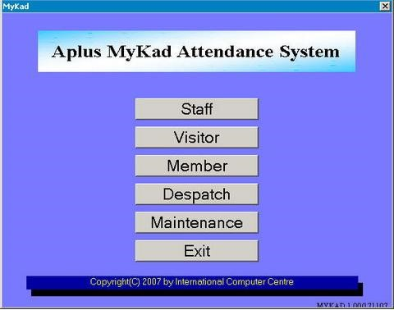

Figure 1.1 main menu of Aplus Mykad attendance System

(Source: Aplus MyKad Attendance System)

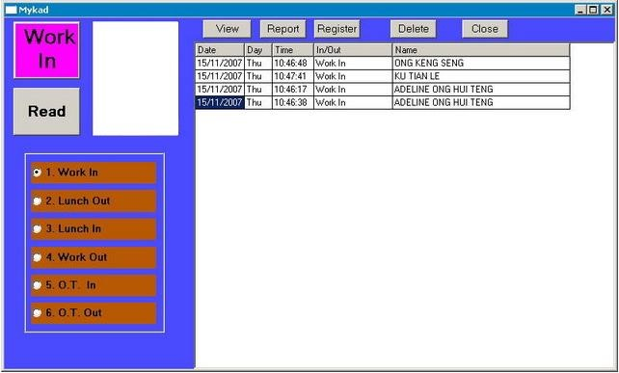

Figure 1.2 Staff Attendance module

(Source: Aplus MyKad Attendance System)

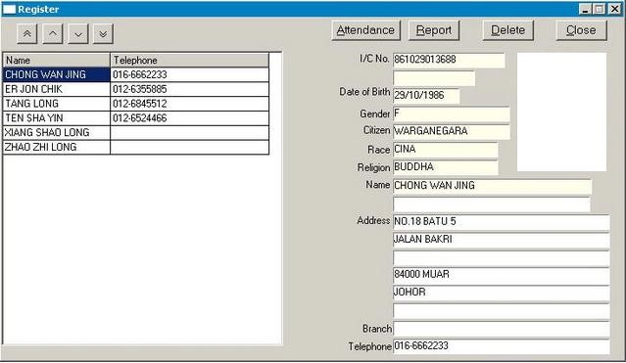

Figure 1.3 Register module

(Source: Aplus MyKad Attendance System)

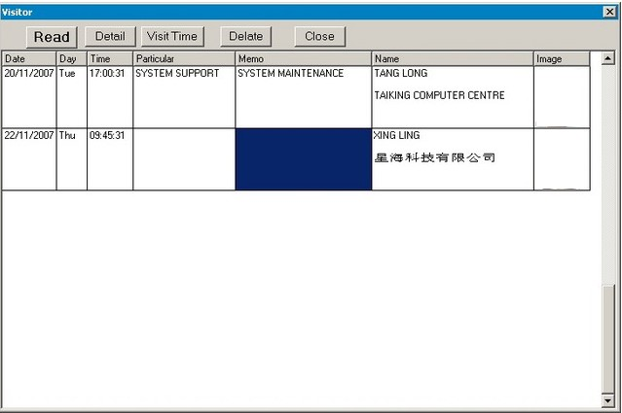

Figure 1.4 Visitor login Module

### 

### **2.3.2 Fingerprint Attendance System**

Fingerprint can be considered as the oldest method and most reliable and popular human characteristics that are widely used for individual identification and verification in the field of biometric technology. Fingerprint is unique because it is believed that no two people will have the same fingerprint pattern in the world.

FingerFlex is an example of fingerprint biometric time attendance system that helps to automate data collection and process timesheets faster. This system can prepare attendance report faster for organizations of any size. Besides that, it can eliminate buddy-punching and improve overall workforce punctuality.

Themainfunctions of FingerFlex Time Attendance System are listed below:

#### 2.3.2.1 One Touch Fingerprint Biometric Time Clock

No password or cards is necessary, FingerFlex Time Attendance will identify staff clocking in and clocking out just by the fingerprint. Figure 1.5 shows the interface of One-Touch Fingerprint Biometric Time Clock.

#### 2.3.2.2 Flexible Schedule Management

This system can also manage work groups and time shifts required. FingerFlex can cater all the time management requirements and manage different working hours for different groups. Figure 1.6 shows the interface for FingFlex system schedule management.

#### 2.3.2.3 Monitor Abnormality

Figure 2.11 shows the interface that used to monitor abnormality of staff attendance. This system has a trigger alert system on monitoring people who are coming late consistently. Companies can set their own rules for late attendance and the system will alert them.

#### 2.3.2.4 Flexible Leave Management

With this feature, staffs who taking leave can be recorded within FingerFlex and will show up in related reports. Figure 2.12 shows the form that employee used fill in to apply leave.

#### 2.3.2.5 Generate Report

Figure 2.13 shows the monthly attendance chart. All the time attendance report generated by FingerFlex can be exported to Microsoft Excel which can then use for payroll calculation or to generate report.

(Source: FingerFlex attendance System)

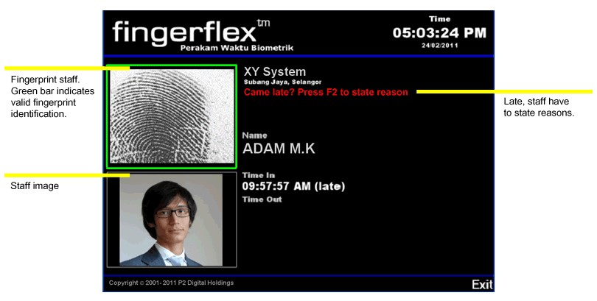

Figure 1.5 One Touch Finger Print Biometric Time Clock

(Source: FingerFlex attendance System)

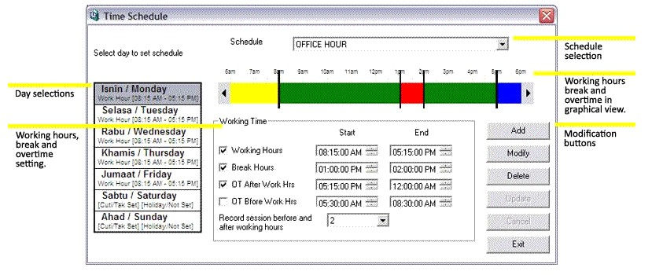

Figure 1.6 Time Schedule Management

### **2.3.3 Client Server Based Attendance System**

Client-server architecture can be considered as a network environment that exchanges information between a server machine and a client machine where server has some resources that can be shared by different clients. TMS Client-Server Attendance System use the concept of Client-Server Architecture. It allows the company to monitor their employees’ attendance from their other branches on real-time based. This contains 2 modules which are client module and server module. In the client module, it has features such as:

1. **Client Login**

For the Client Login page, employee has to key in their Employee Code and Password in order to enter the main page of the system.

1. **Punch in & Out**

Employee used a barcode scanner to punch in and punch out their attendance. Information scanned from barcode will be sent to the system and displayed as the employee data.

(Source: TMS Client-Server Attendance System)

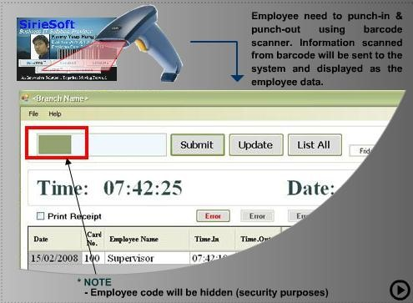

Figure 1.7 Punch in & Out Page

While in the server module, it consists of:

1. **Administration Setting**

This function is created to allow admin to manage the data systematically. Under the administration setting there are leave management which let admin to set the leave’s information, and employee setting is to make admin knows employee details. Assign schedule feature enable admin to arrange the work schedule for the workers. The feature is shown in Figure 1.8 and Figure 1.9.

(Source: TMS Client-Server Attendance System)

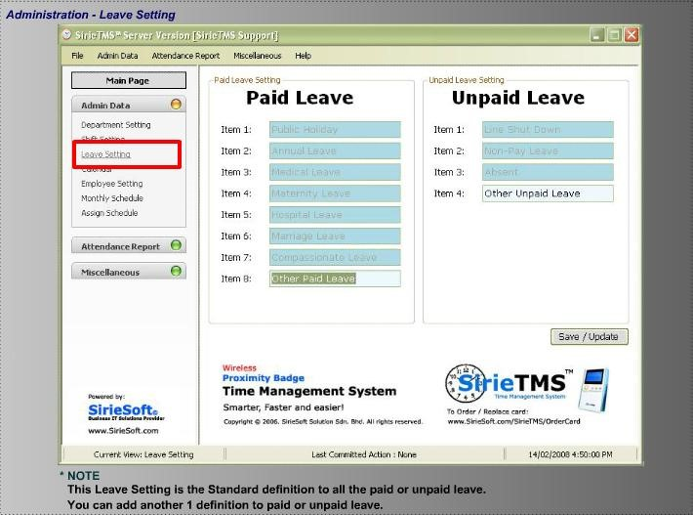

Figure 1.8 Leave Setting

(Source: TMS Client-Server Attendance System)

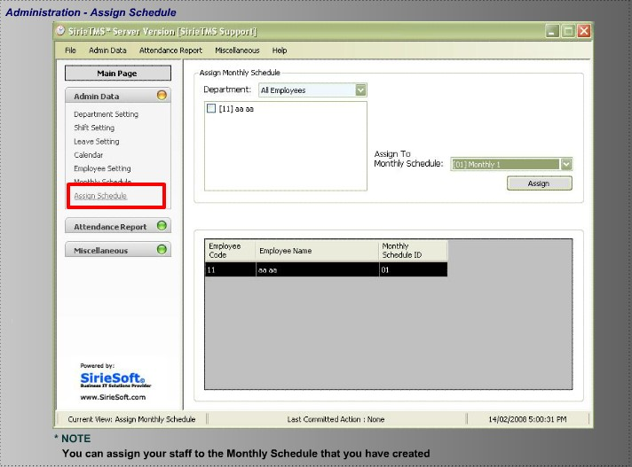

Figure 2.9 Assign Schedule

1. **Attendance Report**

TMS Client-Server attendance system also provides an attendance report function which allows admin to print out any related report easily. The reports that are able to be printed out are: Simple personal report, General report and Performance report.

(Source: TMS Client-Server Attendance System)

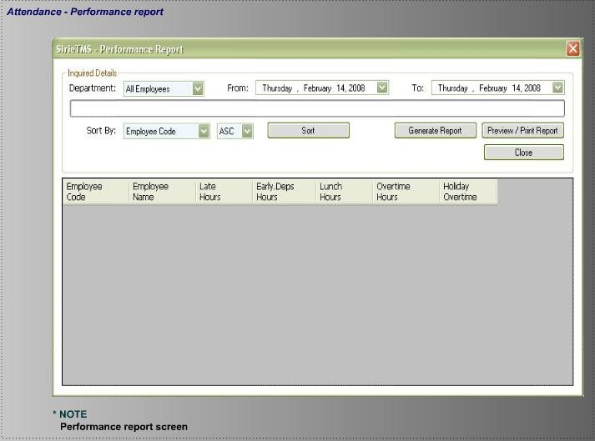

Figure 2.0 Performance Report

## **2.3 Research Gaps**

Smart Card Attendance System e.g. Aplus MyKad is a good system but it’s only for Malaysians since MyKad is the official identity of Malaysia

Fingerprint Attendance System. Fingerprint is unique because it is believed that no two people will have the same fingerprint pattern in the world. The system though good requires purchase of fingerprint devices which are so expensive for Presbyterian College Naivasha

## **2.4 CONCLUSION**

The process of doing research helps to determine the methodology that will be used in this project. The methodology that has been chosen in this project is the Rapid Application Development (RAD) that emphasizes the drawing of models to help visualize and analysis problems, define business requirements and design information system.

# **CHAPTER 3: RESEARCH METHODOLOGY**

## **3.1 Introduction**

This chapter presents the research methodology. The chapter covers research design, population and sampling design, data collection methods, research procedures, data analysis methods and chapter summary.

The chapter describes the methodology that applied in this study. The chapter gives highlights on the research design and details of the research approach was used during the study. Data was collected by use of questionnaires, which was implemented after conducting pre-testing on samples of employees.

## **3.2 Research design**

This section explains the research design that was employed in this study and encompasses the methodology and procedures employed to conduct the study. This study employed experimental research design which is used with the aim of conducting a more precise investigation and in this case it is to explore the use of a window based application to determine how the variables vary efficient employee attendance while maintaining control over all factors that may affect the result of the experiment.

## **3.3 Methodology**

### **3.3.1 Rapid Application Development**

I chose this methodology in my project because it is quick approach used in developing systems taking care of accuracy preference, speed and quality. I had adopted this method and this is clearly seen with the use of CASE techniques applied. Practically RAD commonly termed as RWAD in web scenario comprises of the following phases as were applied in this system:

#### 3.3.1.1 Requirements planning phase

It is the initial stage that would help me in planning a system analysis and documentation requirements.

#### 3.3.1.2 User design phase

This is the structural representation of my project including prototype under which I studied few users view and actions on it.

#### 3.3.1.3 Construction Phase

This phase involves program and application development also called the deployment phase where I was full committed to the implementation.

#### 3.3.1.4 Cutover phase

This marked the termination of the project activities; I will be engaged in testing, changeover and user training.

The following is a diagram showing the phase in Rapid Application Development.

[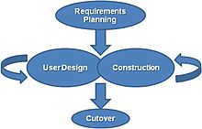](http://en.wikipedia.org/wiki/File:RADModel.JPG)

Figure 2.1 RAD phases

### **3.3.2 Justification of RAD**

#### Time factor

In comparison to other known methodologies, RAD technology will favor my system development with respect to time and quality. This is because RAD employs an increased development speed and decreased delivery time. The goal of delivering applications quickly is addressed through its quick conversion of requirements to code. Taking into account the limited time available to complete a full prototype of the web application, RAD will be the best methodology to use.

#### Increased Quality

According to (Sommerville, 2007), quality is defined as both the degree to which a delivery application meets the needs of the users as well as the degree to which a delivery system has low maintenance costs. RAD attempts to deliver on quality through the involvement of the users in the design stages. Most research conclusions state that user involvement in system development increases the system quality and design.

## **3.4 Population and Sampling Design**

### **3.4.1 Population**

The population of Presbyterian College was 65 staff members and about 300 students. The employees were selected from the various departments in the college.

### **3.4.2 Sample and Sampling Technique**

### **3.4.2.1 Sampling Technique**

#### Random sampling

A sample can be defined as a smaller group or sub group obtained from the accessible population (Mugenda and Mugenda, 1999). Presbyterian college Naivasha constituted the Sample. The sample elements were the employees and students of the college.

The sample size will involve random sampling and the larger the sample, the more accurately it represents the population from which it was taken from. The sample size may depend on factors like degree of accuracy required, amount of variability inherent in the population from which the sample was taken, nature and complexity of the characteristics of the population under consideration. The size of sample will involve at least 10-20 of the staff in the college.

### **3.4.3 Sample Size**

The sample size is a smaller set of the larger population (Schindler, 2006)). Determining sample size is a very important issue for collecting an accurate result within a quantitative survey design. One of the real advantages of quantitative methods is their ability to use smaller groups of people to make inferences about larger groups that would expensive to study (Fisher, 2007). (Mugenda and Mugenda, 2003) argues that the sample must be carefully selected to be representative of the population. According to (Hussey, 1997) no survey can ever be free from error or provide 100 % surety and error limits of less than 10% and confidence levels of higher than 95% can be regarded as acceptable to produce results among variables that are significantly different and it broadens the range of possible data and forms a better picture for analysis.

## **3.5 Data Collection Methods**

### **3.5.1 Questionnaires**

Questionnaires provide a relatively cheap, quick and efficient way of obtaining large amount of information from a sample. Participants were asked to indicate their level of agreement with each statement/item. The main advantage of scaled-responses is that it permitted the measurement of intensity of respondents’ answers compared to multiple choice responses. The scaled responses incorporate numbers which can be used directly as codes (McDaniel & Gates, 2001). The scaling procedure determines quantitative measures of subjective and abstract concepts (Chin et al, 2003). The study aimed to gather primary data; collected for the first time and thus “original in character” Kothari, (2006). The advantage of close-ended choices ensured that the respondent simply places a tick in a box by the selected answer(s) and reduces the potential for respondent variability and thus facilitating the processing of collected data (Bryan, 2012). The questionnaire had sufficient questions for collection of relevant information required to achieve the purpose of the study. Questions were organized on issue-based structured pattern following the sub-elements of the stated research questions, so as to ensure completeness.

**Ethical considerations**

Respondents will be assured of their anonymity and that the data collected will only be used for this research. The research will benefit the respondents by making them participate in development of a system that affects them

## **Data Analysis and Presentation**

### **3.6.1 Data analysis**

The collected data was analyzed using Microsoft excel (2013) because it can build great charts, Help identify trends, bring data together, uses conditional formatting and has online access. Availability and ease of use of the software

### **3.6.2 Data Presentation**

Data will be presented using pie charts. This is pie chart summarize a large set in visual form

## **3.7 Functional specification**

It deals with the functionalities required from the system which are as follows

System Managers/ Admin will be responsible for:

1. Manage user accounts.
2. Manage reports
3. Manage system database and ensure regular backup of data
4. Manage employee profile

## **3.8 Non Functional requirements**

#### Portability

The system is transferable to other machines because it is built on open source languages.

#### Security

Since the system store’s sensitive personnel data, several measures have been initiated such as the use of passwords and user names to log into the system.

#### Ease of access

It will be easy to navigate through the system since the system will have menu driven interface making it simple for use.

### **3.8.1 System requirements**

A computer with the following specifications will be required:

Speed: at least 2.0 GHZ

Memory: at least 1GB RAM

Storage space: at least 80GB hard disk

MYSQL/ ACCESS/ ORACLE DATABASE

Windows 7/8.1/10 Operating system

Java development kit(JDK 7.2 or above)

## **3.9 Logical design**

A design is used to structure the research, to show how all of the major parts of the research project are hosted in their current environs.

### **3.9.1 Activity diagram.**

The following shows the actions done by the users:

**NOTE:** the database administrator creates a user account before successful login as a security mechanism; this is just one of the many controls that can be used as a security control in an IS.

#### An activity diagram involving an administrator

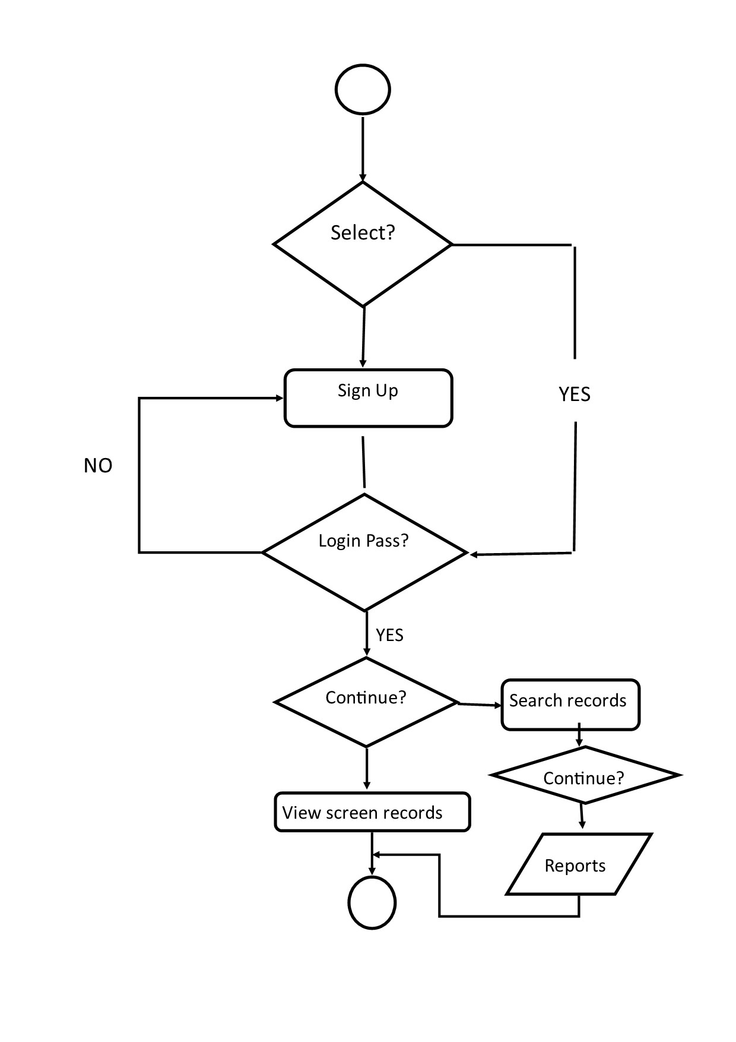

Figure 2.2 Activity Diagram

### **3.9.2 Use Case Diagram**

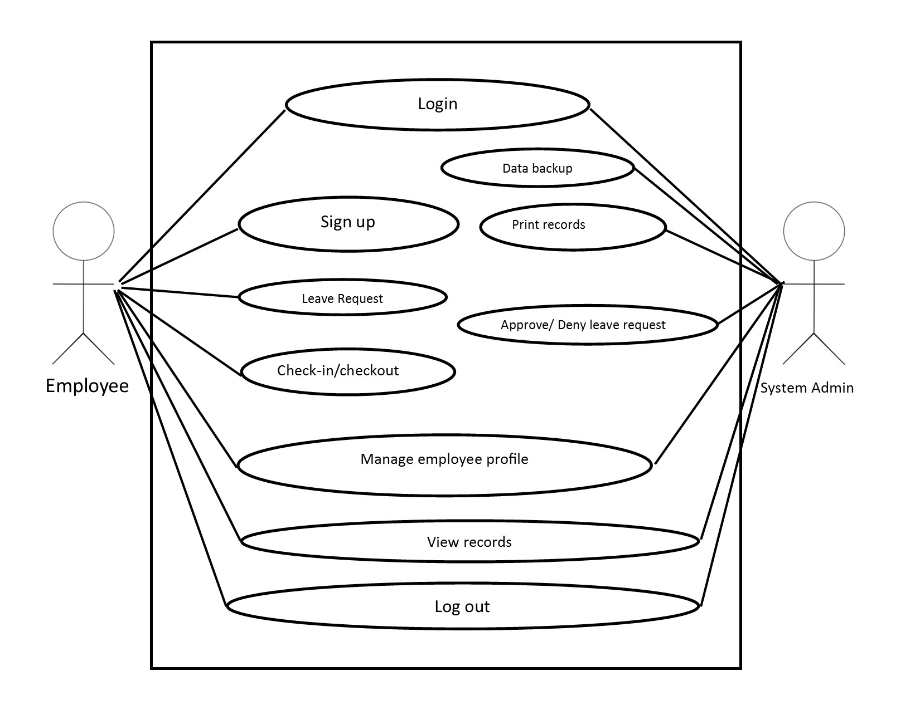

Figure 2.3 Use Case Diagram

## **Chapter Summary**

The chapter has detailed the research methodology that was used in carrying out the study. The chapter covered research design, data collection methods, and research procedures and data analysis.

# **CHAPTER FOUR: RESEARCH FINDINGS AND TESTING**

## **4.1 INTRODUCTION**

This study was at determining the challenges of manual system of managing employee attendance and how it can be computerized through user friendly windows application that will ease attendance process. The specific objectives of this study included review and analyzing the current system, design, develop and test a window application that will make storage of employee details easy without any data loss

## **4.2 SYSTEM CONSTRUCTION**

### **4.2.1 LOGIN WINDOW**

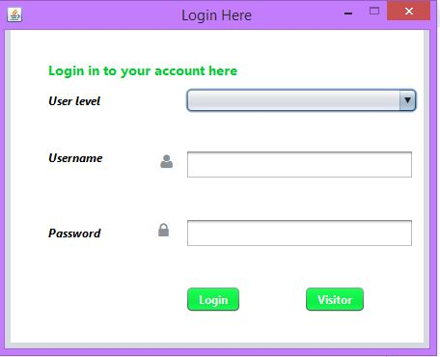

Source:EAS

Figure 2.4 login window

The screenshot pictured above shows the login screen of employee attendance system where employees and admin are able to input their details and have the system validate their credentials before allowing access to the system. Depending on user level different main windows are displayed

### **4.2.2 Admin main window**

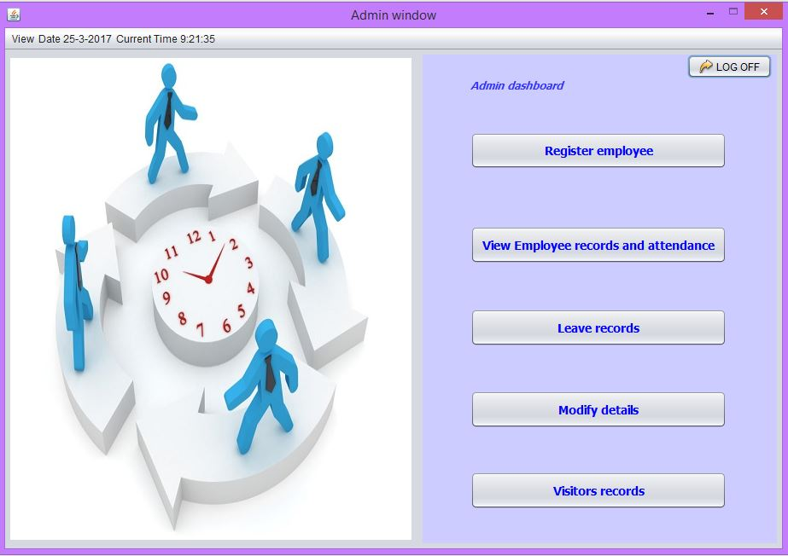

Source: EAS

Figure 2.5 Admin main window

After the system verifies the user to be admin he/she is directed to the admin main window as it is the screenshot above

### **4.2.3 User main window**

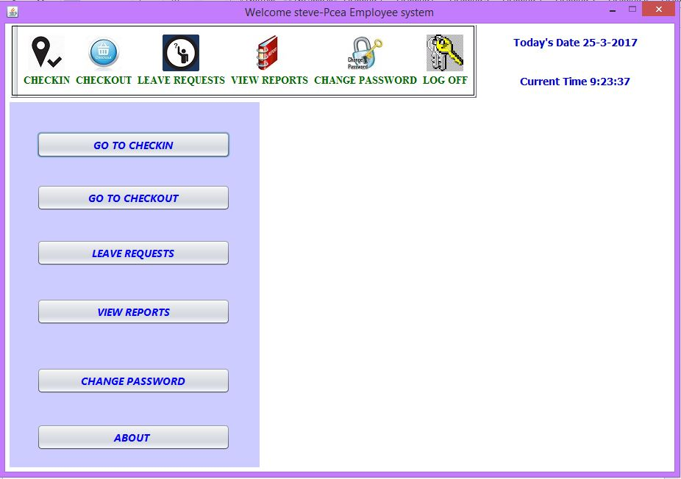

Source:EAS

Figure 2. 6 User main window

Screenshot pictured above is the user main window where several operation such as check in, check out, leaves, offs, view reports and change password can be performed

## **4.2.4 Register new Employee window**

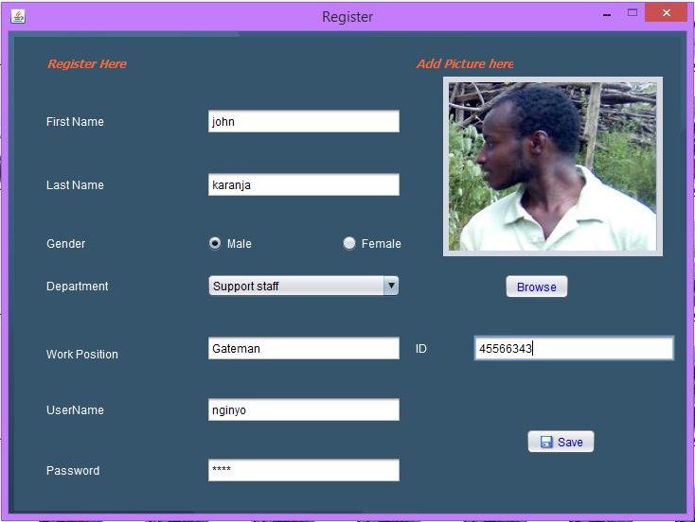

Source: EAS

Figure 2.7 Registration window

For the addition of new employee the system admin will login and therefore register the details into the database accordingly.

## **4.2.5 Reports viewing and Printing**

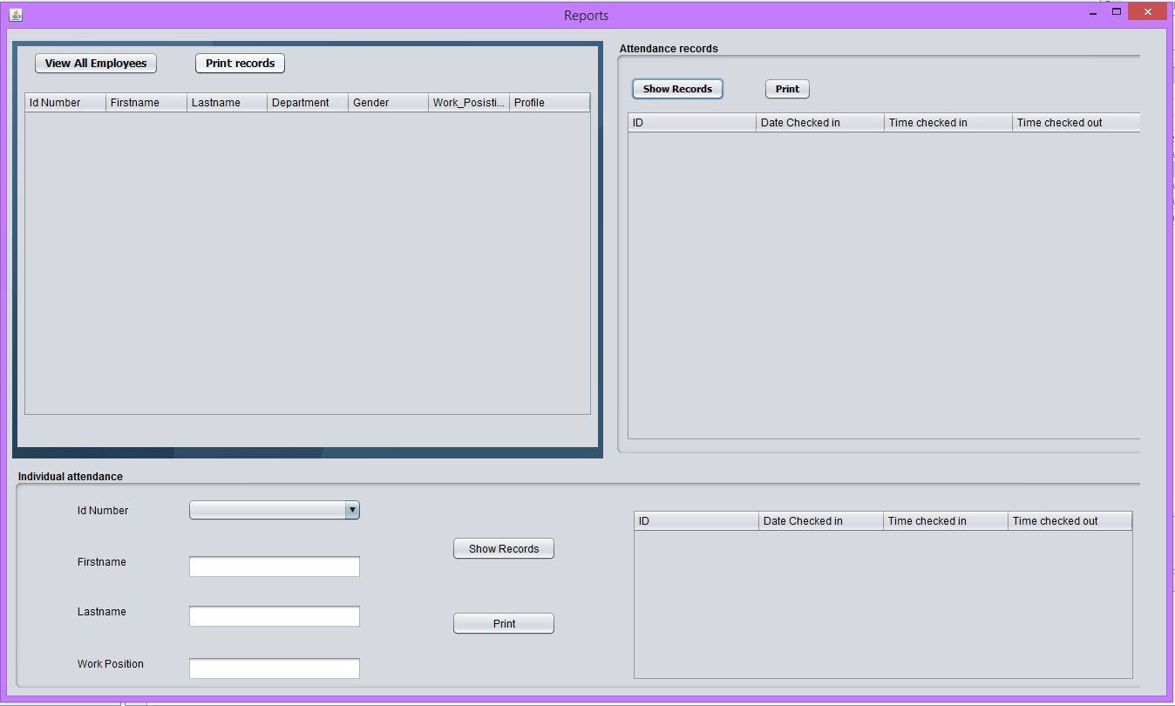

Source: EAS

Figure 2.8 Reports viewing and printing

In the Screenshot pictured above employee details and attendance records can be viewed and be printed. Also individual employee records are viewable by selecting on his id and be printed

## **4.3 Testing**

System testing involves testing the system to validate that it meets user specifications and objectives.

System test objectives are;

1. To analyze the test results
2. Test the system against user requirements

The components to be tested are;

1. To test the system to validate it only accepts valid data.
2. Check whether the system is giving desired output.

### **4.3.1 Testing Strategy**

This involved testing the system using different types of system test that were performed on the system. This is aimed at uncovering errors and measuring the system capability.

### **4.3.2 User Acceptance Testing**

A post development questionnaire was distributed to employees at Presbyterian College Naivasha and from the results, the evaluation of the system showed that it met the user needs and achieved a high level of acceptance and level of performance. The new application was exceptionally accepted (85% acceptance) with respect to functionality, user interface, ease of learning and usability.

Do you think the platform used (i.e window application) for development best suits your organization?

|  |  |  |
| --- | --- | --- |
| Yes | No | Maybe |
| 85% | 5% | 10% |

.

Figure 2.9 User Acceptance testing

# **CHAPTER 5**

# **SUMMARY, CONCLUSION AND RECOMENDATIONS**

## **5.1 Introduction**

This chapter gives a summary and a conclusion of the whole research. It also gives recommendations on employee attendance management process and proposes various areas of further studies that researchers may venture.

## **5.2 Summary**

The overall objective of this project was to develop EAS which is a window based system that will help improve employees’ attendance and records management. This system will help in check in and checkout and easily generate reports whenever they are needed.

The system runs on windows operating system and therefore can be installed on any machine. JAVA programming language was used to code the system while MySQL was used as a database engine of choice to implement the service side where the data is stored.

The users were involved and consulted during the project and especially during the implementation of the product. Overall most of the users preferred the system while some who had issues with it gave the researcher the feedback which helped in making the system better as desired. User changes were aimed at the project specification to be achieved and hand over the desired results of the system.

## **5.3 Conclusion**

The evaluation of employment commitment towards depends on attendance records. Although the evaluation is done on observing how the employees attend there is no real-time monitoring of their attendance. Presence of technology is bringing a difference in the Human resource sector by increasing quality of attendance monitoring and efficiency performance evaluation criteria. This is made possible by use of EAS which allows employees to check in and check out and there data is stored on a central system. EAS reduces time costs since employees need only to login to the system and fill in there and attendance by click of one button and can easily view his/her attendance report.

## **5.4 Recommendations**

Since the current EAS application version is only in English it should accommodate both English and Swahili languages.

Technology is growing day by day. People are moving from desktop to mobile application. EAS can be improved to be a mobile application

# **References**

Fisher. (2007). Retrieved from mdh.diva-portal.org/smash/get/diva2:290949/FULLTEXT01.pdf

Gates, M. a. (2001). Retrieved from shodhganga.inflibnet.ac.in/bitstream/10603/28785/10/10_chapter%205.pdf

Hussey, H. a. (1997). Retrieved from erepo.usiu.ac.ke/bitstream/handle/11732/198/NATALIE%20.pdf?sequence=1.

Kombo, O. a. (2002). Retrieved from www.hrpub.org/download/20131107/WJCAT4-13701425.pdf

Mugenda, M. a. (1999).

Mugenda, M. a. (1999). Retrieved from www.ijsrp.org/research-paper-0415/ijsrp-p40116.pdf

Schindler, C. a. (2006). *Review_of_literature_and_studies-sampling.* Retrieved from http://www.academia.edu/4671319/Review_of_literature_and_studies-sampling: http://www.academia.edu/4671319/Review_of_literature_and_studies-sampling

Sommerville. (2007). Retrieved from soar.wichita.edu:8080/bitstream/handle/10057/11598/d15012_Kanan.pdf?sequence=1

Liu, J., E.D. Love, P., Smith, J., Regan, M., & Sutrisna, M. (2014). Public-Private Partnerships: a review of theory and practice of performance measurement. *Int J Productivity & Perf Mgmt,* 63(4), 499-512.

Bridger, E. (2014). *Employee engagement*. London: Kogan Page.

[www.google.com](http://www.google.com)

[www.wikipedia.com](http://www.wikipedia.com)

# **APPENDICES**

## **APPENDIX A: POST-DEVELOPED QUESTIONNAIRE**

1. Is the system Interactive?

a) Strongly Agree b). Agree c). Disagree d). Strongly Disagree

2. Is the Usability of the system easy?

a) Strongly Agree b). Agree c). Disagree d). Strongly Disagree

3. Does the system feature the basic modules required for attendance evaluation?

a) Yes b) No

4. Has the system improved the operations of Performance Evaluation?

a) Strongly Agree b). Agree c). Disagree d). Strongly Disagree

5. What is your level of remembrance to use the system?

a) Easy b) Difficult

## 

## **APPENDIX B: BUDGET AND REQUIREMENTS**

|  |  |
| --- | --- |
| **Description** | **Amount(Kshs.)** |
| Transport | 2000 |
| Printing | 1000 |
| Computer | 40000 |
| Flash Disk(8gb) | 1200 |
| Photocopy | 500 |
| Total | 44700 |

## 

## **APPENDIX C:** **LOGICAL SCHEDULE OF THE PROJECT**

|  |  |  |  |
| --- | --- | --- | --- |
| Index | Description | Duration | Deliverable |
| 1. | Project Tittle | 2weeks | Meeting supervisor |
| 2. | Problem statement | 2weeks | Problem statement |
| 3. | Literature review | 3weeks | Review exising systems |
| 4. | System Analysis | 3weeks | System specification |
| 5.  6.  7.  8.  9.  10. | Presentation  System Design  Impelementation / coding  walkthrough  Evaluation/Testing  Presentation | 2days  2weeks  6weeks  1week  2weeks  2days | Proposal presentation  prototyping  System Implementation  Final system  Report user satisfication  System demonstration |

## **APPENDIX D: WORK PLAN**

|  |  |  |  |  |  |  |  |  |  |  |  |  |  |  |  |  |  |  |  |  |  |  |
| --- | --- | --- | --- | --- | --- | --- | --- | --- | --- | --- | --- | --- | --- | --- | --- | --- | --- | --- | --- | --- | --- | --- |
| **Activity** | **1** | **2** | **3** | **4** | **5** | **6** | **7** | **8** | **9** | **10** | **11** | **12** | **13** | **14** | **15** | **16** | **17** | **18** | **19** | **20** | **21** | **22** |
| Project title |  |  |  |  |  |  |  |  |  |  |  |  |  |  |  |  |  |  |  |  |  |  |
| Problem statement |  |  |  |  |  |  |  |  |  |  |  |  |  |  |  |  |  |  |  |  |  |  |
| Literature review |  |  |  |  |  |  |  |  |  |  |  |  |  |  |  |  |  |  |  |  |  |  |
| Systems analysis |  |  |  |  |  |  |  |  |  |  |  |  |  |  |  |  |  |  |  |  |  |  |
| System Design |  |  |  |  |  |  |  |  |  |  |  |  |  |  |  |  |  |  |  |  |  |  |
| Implementation |  |  |  |  |  |  |  |  |  |  |  |  |  |  |  |  |  |  |  |  |  |  |
| Testing and evaluation |  |  |  |  |  |  |  |  |  |  |  |  |  |  |  |  |  |  |  |  |  |  |
| Documentation |  |  |  |  |  |  |  |  |  |  |  |  |  |  |  |  |  |  |  |  |  |  |
| Presentation |  |  |  |  |  |  |  |  |  |  |  |  |  |  |  |  |  |  |  |  |  |  |